Nama : Adridinan Najmi Faza
NIM : H1D025059

- Membuat tabel sesuai buku
MariaDB [(none)]> create database penjualan_barang;
Query OK, 1 row affected (0.001 sec)
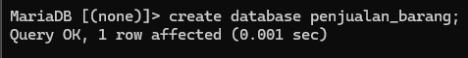
MariaDB [penjualan_barang]> create table pelanggan
-> id_pelanggan varchar(10) not null primary key,
-> nama varchar(40) not null,
-> Alamat VARCHAR(255),
-> Pekerjaan VARCHAR(50),
-> No_ktp VARCHAR(20),
-> No_telp VARCHAR(15));
Query OK, 0 rows affected (0.013 sec)
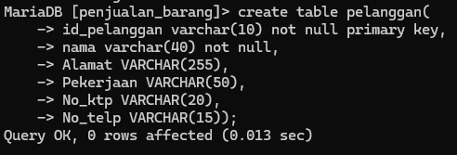
MariaDB [penjualan_barang]> create table barang(
-> id_barang varchar(10) not null primary key,
-> nama_barang varchar(100) not null,
-> harga int(10) not null,
-> stok int not null);
Query OK, 0 rows affected (0.013 sec)
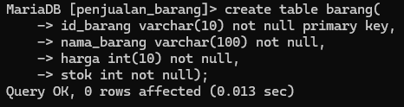
MariaDB [penjualan_barang]> create table nota_penjualan(
-> id_nota varchar(10) not null primary key,
-> tgl_nota date not null,
-> total int,
-> id_pelanggan varchar(10) not null,
-> foreign key (id_pelanggan) references pelanggan(id_pelanggan));
Query OK, 0 rows affected (0.021 sec)
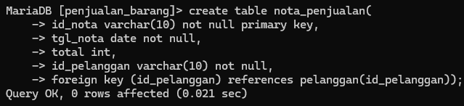

MariaDB [penjualan_barang]> CREATE TABLE Detail_Jual (
-> id_nota VARCHAR(10) NOT NULL,
-> id_barang VARCHAR(10) NOT NULL,
-> jumlah INT NOT NULL,
-> harga int(10) not null,
-> PRIMARY KEY (Id_Nota, Id_Barang),
-> FOREIGN KEY (id_nota) REFERENCES Nota_Penjualan(id_nota),
-> FOREIGN KEY (id_barang) REFERENCES Barang(id_barang));
Query OK, 0 rows affected (0.026 sec)
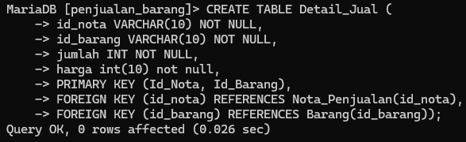

- Show table yang telah di buat
MariaDB [(none)]> use penjualan_barang;
Database changed
MariaDB [penjualan_barang]> show tables;
+----------------------------+
| Tables_in_penjualan_barang |
+----------------------------+
| barang |
| detail_jual |
| nota_penjualan |
| pelanggan |
+----------------------------+
4 rows in set (0.001 sec)
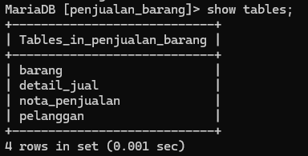

- Desc tabel yang telah di buat
MariaDB [penjualan_barang]> desc barang;
+-------------+--------------+------+-----+---------+-------+
| Field | Type | Null | Key | Default | Extra |
+-------------+--------------+------+-----+---------+-------+
| id_barang | varchar(10) | NO | PRI | NULL | |
| nama_barang | varchar(100) | NO | | NULL | |
| harga | int(10) | NO | | NULL | |
| stok | int(11) | NO | | NULL | |
+-------------+--------------+------+-----+---------+-------+
4 rows in set (0.017 sec)
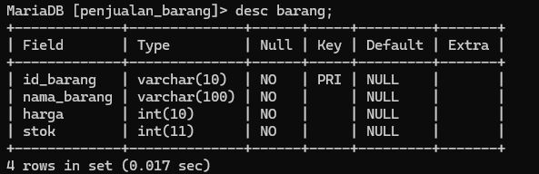
MariaDB [penjualan_barang]> desc detail_jual;
+-----------+-------------+------+-----+---------+-------+
| Field | Type | Null | Key | Default | Extra |
+-----------+-------------+------+-----+---------+-------+
| id_nota | varchar(10) | NO | PRI | NULL | |
| id_barang | varchar(10) | NO | PRI | NULL | |
| jumlah | int(11) | NO | | NULL | |
| harga | int(10) | NO | | NULL | |
+-----------+-------------+------+-----+---------+-------+
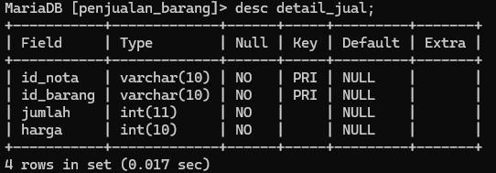
4 rows in set (0.017 sec)

MariaDB [penjualan_barang]> desc nota_penjualan;
+--------------+-------------+------+-----+---------+-------+
| Field | Type | Null | Key | Default | Extra |
+--------------+-------------+------+-----+---------+-------+
| id_nota | varchar(10) | NO | PRI | NULL | |
| tgl_nota | date | NO | | NULL | |
| total | int(11) | YES | | NULL | |
| id_pelanggan | varchar(10) | NO | MUL | NULL | |
+--------------+-------------+------+-----+---------+-------+
4 rows in set (0.011 sec)
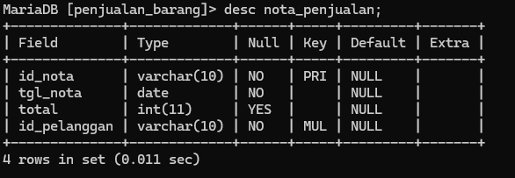

MariaDB [penjualan_barang]> desc pelanggan;
+--------------+--------------+------+-----+---------+-------+
| Field | Type | Null | Key | Default | Extra |
+--------------+--------------+------+-----+---------+-------+
| id_pelanggan | varchar(10) | NO | PRI | NULL | |
| nama | varchar(40) | NO | | NULL | |
| Alamat | varchar(255) | YES | | NULL | |
| Pekerjaan | varchar(50) | YES | | NULL | |
| No_ktp | varchar(20) | YES | | NULL | |
| No_telp | varchar(15) | YES | | NULL | |
+--------------+--------------+------+-----+---------+-------+
6 rows in set (0.015 sec)
